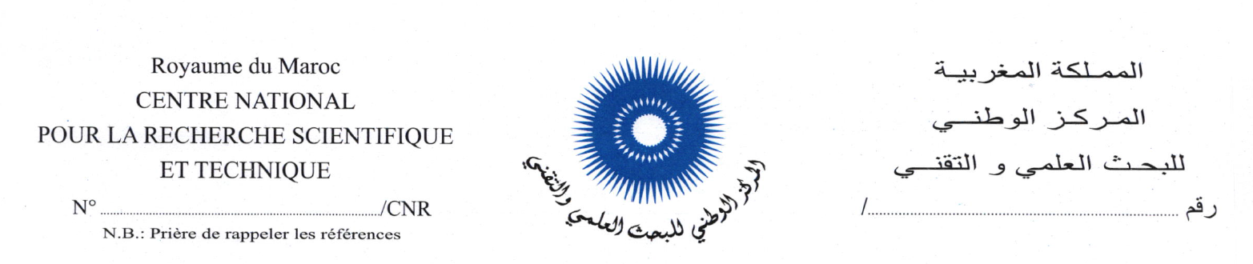

PHOTO

DOSSIER DE CANDIDATURE

Poste concerné : ……………………………………

ETAT CIVIL

Nom de famille :…………………………………………………………………………………
Prénom :………………………………………………………………………………………..
Date de naissance :………………………. ………………………………………………….. Lieu de naissance :……………………… Province ou préfecture :………………………
N° CIN :………………………………… PPR : …………………………………………
Date de recrutement dans l’administration :………………………………… …………….
Grade (Echelle) :………………………… ………………………………… ………………..
Affectation actuelle : …………………………………………………………………………..
……………………………………………………………………………………

Situation familiale : Célibataire |  | Marié (e) |  | Divorcé(e) |  | Veuf (ve)
Téléphone (Bureau) :……………………………………………………………………………
Téléphone (Domicile / GSM):……….…………………………………………………………
E-Mail : ………………………………………………………………………................………….

DIPLOMES ET FORMATION :

Diplôme obtenu | Etablissement | Ville / Pays | Année d’obtention.

- Formation continue et stage (du plus récent au plus ancien):

Formation | Durée | Année | Etablissement | Ville /pays

EXPERIENCES PROFESSIONNELLES

- Postes occupés dans l’administration (du plus récent au plus ancien)

Direction | Division / service | Poste / fonction occupés | Période
Direction | Division / service | Poste / fonction occupés | du | Au

- Postes occupés dans le secteur Privé (le cas échéant)

Organisme / Société | Poste / fonction occupés | Période
Organisme / Société | Poste / fonction occupés | du | au

CONNAISSANCES EN INFORMATIQUE

- ………………………………………..
- …………………………………………
- …………………………………………..
- …………………………………………

LANGUES

 | Arabe | Français | Anglais | Espagnol | Autres
Lue
Ecrite
Parlée

Qualifications :

Connaissances :

……………………………………………………………………………………………………………………………………………………………………………………………………………………………………………………………………………………………………………………………………………………………………………………………………………………………………………………………………………………………………………………………………………………………………………..……………………………………………………………………………………………………………………………………………………………………………………………………………………………………………………………………………………………………………………………………………………………………………………………………………………………………………………………..

- Expériences :
…………………………………………………………………………………………………………………………………………………………………………………………………………………………………………………………………………………………………………………………………………………………………………………………………………………………………………………………………………………………………………………………………………………………………………………………………………………………………………………………………………………………………………………………………………………………………………………………………………………………………………………………………………………………………………………..……………………………………………………………………………………………………………………………………………………………………………………………………………………………………………………………………………………………………………………………………………………………………………………………………………………………………………………………..……………………………………………………………………………………………………………………………………………………………………………………………………………………………………………………………………………………………………………………………………………………………………………………………………………………………………………………………..

- Compétences :
……………………………………………………………………………………………………………………………………………………………………………………………………………………………………………………………………………………………………………………………………………………………………………………………………………………………………………………………..……………………………………………………………………………………………………………………………………………………………………………………………………………………………………………………………………………………………………………………………………………………………………………………………………………………………………………………………..………………………………………………………………………………………………………………………………………………………………………………………………………………………………………………………………………………………………………………………………………………………………………………………………………………………………………………………………………………………………………………………………………………………………………………………………………………………………………………………………………………………………………………………………………………………………………………………………………………

VISION STRATIGIQUE DU POSTE POUR LEQUEL VOUS POSTULEZ

…………………………………………………………………………………………………………………………………………………………………………………………………………………………………………………………………………………………………………………………………………………………………………………………………………………………………….………………
………………………………………………………………………………………………………………………………………………………………………………………………………………………………………………………………………………………………………………………………………………………………………………………………………………………………………………….…
………………………………………………………………………………………………………………………………………………………………………………………………………………………………………………………………………………………………………………………………………………………………………………………………………………………………………………………………………………………………………………………………………………………………………………………………………………………………………………………………………………………………………………………………………………………………………………………………………………………………………………………………………………………………………………………………………………………………………………………………………………………………………………………………………………………………………………………………………………………………………………………………………………………………………………………………………………………………………………………………………………………………………………………………………………………………………………………………………………………………………………………………………………………………………………………………………………………………………………………………………………………………………………………………………………………………………………………………………………………………………………………………………………………………………………………………………………………………………………………………………………………………………………………………………………………………………………………………………………………………………………………………………………………………………………………………………………………………………………………………………………………………………………………………………………………………………………………………………………………………………………………………………………………………………………………………………………………………………………………………………………………………………………………………………………………………………………………………………………………………………………………………………………………………………………………………………………………………………………………………………………………………………………………………………………………………………………………………………………………………………………………………………………………………………………………………………………………………………………………………………………………………………………………………………………………………………………………………………………………………………………………………………………………………………………………………………………………………………………………………………………………………………………………………………………………………………………………………………………………………………………………………………………………………………………………………………………………………………………………………………………………………………………………………………………………………………………………………………………………………………………………………………………………………………………………………………………………………………………………………………………………………………………………………………………………………………………………………………………………………………………………………………………………………………………………………………………………………………………………………………………………………………………………………………………………………………………………………………………………………………………………………………………………………………………………………………………………………………………………………………………………………………………………………………………………………………………………………………………………………………………………………………………………………………………………………………………………………………………………………………………………………

ENGAGEMENT

Je certifie que les informations ci-dessus sont exactes et complètes.

Fait à …………….………le,………………………..

Signature du candidat

AVIS ET APPRECIATIONS

Autorisation de L'Administration pour les employés en dehors du centre:

…………………………………………………………………………………………………………
…………………………………………………………………………………………………………
…………………………………………………………………………………………………………
…………………………………………………………………………………………………………
…………………………………………………………………………………………………………
…………………………………………………………………………………………………………
…………………………………………………………………………………………………………
…………………………………………………………………………………………………………
…………………………………………………………………………………………………………

Fait à…………….………., le………….…………

Signature

