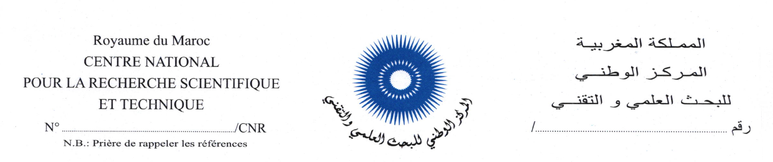

صورة حديثة

ملف الترشيح

لمنصب رئيس ..................................................................................
بالمركز الوطني للبحث العلمي والتقني
- الحالة المدنية

الاسم العائلي..............................................................................................................................Nom
الاسم الشخصي......................................................................................................................Prénom
تاريخ ومكان الازدياد...........................................................................................................................

 | أرمل |  | مطلق |  | متزوج |  | عازب | الحالة العائلية :

رقم بطاقة التعريف الوطنية................................رقم التأجير.........................................................................
تاريخ التوظيف بالإدارة العمومية...............................................................................................................
الدرجة..................................................................السلم......................................الرتبة.........................
التعيين الحالي.....................................................................................................................................
رقم الهاتف (المكتب).....................................................النقال : ...............................................................
البريد الإلكتروني : ..............................................................................................................................

- الشهادات (من الأحدث إلى الأقدم) :

الشهادة أو الدبلوم | المؤسسة | المدينة/البلد | تاريخ الحصول على الشهادة

- التكوين المستمر والتداريب (من الأحدث إلى الأقدم) :

موضوع التكوين | المدة | السنة | المؤسسة/الهيئة | المدينة/البلد

- التجربة المهنية :

- المناصب التي تم شغلها بالإدارة العمومية والجماعات الترابية أو المؤسسات العمومية

الفترة |  | المديرية | القسم/المصلحة | المنصب/الوظيفة
إلى | من

- المناصب التي تم شغلها بالقطاع الخاص

الفترة |  | هيئة/شركة | المنصب/الوظيفة
إلى | من

- المؤهلات في ميدان المعلوميات :

…………………………………………………………………………………………………………………………………………………………………………………………………………………………………………………………………………………………………………………………………………………………………………………………………………………………………………………………………………………………………………………………………………………………………

- اللغـــات :

 | العربية | الأمازيغية | الفرنسية | الإنجليزية | الإسبانية | أخرى
مقروءة
مكتوبة
منطوقة

- المؤهلات :

- المعارف :
……………………………………………………………………………..............................................……………………………………………………………………………..............................................……………………………………………………………………………..............................................……………………………………………………………………………..............................................……………………………………………………………………………..............................................……………………………………………………………………………..............................................……………………………………………………………………………..............................................……………………………………………………………………………..............................................……………………………………………………………………………..............................................……………………………………………………………………………..........................

- التجارب : ……………………………………………………………………………..............................................……………………………………………………………………………..............................................……………………………………………………………………………..............................................……………………………………………………………………………..............................................……………………………………………………………………………..............................................……………………………………………………………………………..............................................……………………………………………………………………………..............................................……………………………………………………………………………..............................................……………………………………………………………………………..............................................……………………………………………………………………………..............................................……………………………………………………………………………..............................................……………………………………………………………………………..............................................……………………………………………………………………………..............................................……………………………………………………………………………..............................................……………………………………………………………………………..............................................……………………………………………………………………………..............................................……………………………………………………………………………..............................................……………………………………………………………………………..............................................……………………………………………………………………………..............................................……………………………………………………………………………..............................................……………………………………………………………………………........................................................................................................................................................

- الكفاءات:

……………………………………………………………………………..............................................……………………………………………………………………………..............................................……………………………………………………………………………..............................................……………………………………………………………………………..............................................……………………………………………………………………………..............................................……………………………………………………………………………..............................................……………………………………………………………………………..............................................……………………………………………………………………………..............................................……………………………………………………………………………..............................................……………………………………………………………………………..............................................……………………………………………………………………………........................

برنامج العمل والمنهجية التي يقترحها المترشح(ة) لتدبير الوحدة الإدارية المعنية وتطويرها والرفع من أدائها:

………………………………………………………………………………………………………………………………………………………………………………………………………………………………………………………………………………………………………………………………………………………………………………………………………………………………………………………………………………………………………………………………………………………………………………………………………………………………………………………………………………………………………………………………………………………………………………………………………………………………………………………………………………………………………………………………………………………………………………………………………………………

…………………………………………………………………………………………………………………………………………………………………………………………………………………………………………………………………………………………………………………………………………………………………………………………………………………………………………………………………………………………………………………………………………………………………………………………………………………………………………………………………………………………………………………………………………………………………………………………………………………………………………………………………………………………………………………………………………………………………………………………………………………………………………………………………………………………………………………………………………………………………………………………………………………………………………………
……………………………………………………………………………………………………………………………………………………………………………………………………………………………………………………………………………………………………………………………………………………………………………………………………………………………………………………………………………………………………………………………………………………………………………………………………………………………………………………………………………………………………………………………………………………………………………………………………………………………………………………………………………………………………………………………………………………………………………………………………………………………………………………………………………………………………………………………………………………………………………………………………………………………………………………………………………………………………………………………………………………………………………………………………………………………………………………………………………………………………………………………………………………………………………………………………………………………………………………………………………………………………………………………………………………………………………………………………………………………………………………………………………………………………………………………………………………………………………………………………………………………………………………………………………………………………………………………………………………………………………………………………………………
……………………………………………………………………………………………………………………………………………………………………………………………………………………………………………………………………………………………………………………………………………………………………………………………………………………………………………………………………………………………………………………………………………………
……………………………………………………………………………………………………………………………………………………………………………………………………………………
……………………………………………………………………………………………………………………………………………………………………………………………………………………………………………………………………………………………………………………………………………………………………………………………………………………………………………………………………………………………………………………………………………………
…………………………………………………………………………………………………………………………………………………………………………………………………………………………………………………………………………………………………………………………………………………………………………………………………………………………………………

تصريح : أشهد على صحة المعلومات الواردة في هذا المطبوع.

حرر ب............................... بتاريخ...................................

التوقيع

ملحوظة : يتعين عند الاقتضاء الإدلاء بالوثائق التي تؤكد صحة البيانات المشار إليها أعلاه.

الموافقة:

- موافقة الإدارة للموظفين من خارج المركز:

…………………………………………………………………………………………………………
…………………………………………………………………………………………………………
…………………………………………………………………………………………………………
…………………………………………………………………………………………………………
…………………………………………………………………………………………………………
…………………………………………………………………………………………………………
…………………………………………………………………………………………………………

حرر ب.........................بتاريخ.............................

التوقيع

